Graduation Project Proposal

Project Information
Project Title | Department/Faculty/University | Project Field/Discipline
Wareeny – An assistive app for blind and visually impaired individuals | Computer Science – Faculty of Computers & Information Technology - FUE
Advisors’ Names | Advisors’ Mobile Numbers | Advisors’ Email Addresses
Prof. Abeer El Korany |  | Abeer.ElKorany@fue.edu.eg
Linah Mohamed |  | Linah.Elnaghi@fue.edu.eg
Students’ Names | Students’ Mobile Numbers | Students’ Email Addresses
Omar Ahmed said |  | 20225281@fue.edu.eg
Youssef Amr |  | 20221949@fue.edu.eg
Mohamed Wael |  | 20223960@fue.edu.eg
Mohamed Moataz |  | 20223394@fue.edu.eg
Ahmed Mohamed |  | 20223031@fue.edu.eg
Mohamed Khaled |  | 20224727@fue.edu.eg

Is this project part of a mega-project at the same institution? Yes No (If yes, please submit all proposals together.)
If the project is sponsored by or initiated by an ICT company, please state its name:
Motivation
Please write why you chose this project idea, explaining clearly the problem that the project is addressing
Motivation:
This idea was chosen due to the need among visually impaired individuals for accurate, accessible assistive tools. In Arabic speaking populations, no existing solutions offer any comprehensive text or voice recognition in Arabic, leaving many users excluded or unable to engage with local signage, product labels, and documents effectively.
Handle Blind People Problems Such as:
Accessibility gap: Most AI assistive apps (like Seeing AI, Be My Eyes, Envision AI) are mainly optimized for English and a few other languages. They lack Arabic OCR and speech support, leaving millions of visually impaired Arabic speakers underserved.
Performance issues: Existing apps often fail in object detection accuracy, over-describe scenes, or can’t recognize local currencies, products, or Arabic text.
Local relevance: Blind users in Arabic-speaking countries can’t get accurate help with Arabic menus, medication labels, or shop signs, that are routine and necessary for independence.
Social impact: This project promotes digital inclusion, allowing visually impaired users to navigate the world independently.

Availability of Data:
Training Data for Object Detection: Open datasets like COCO (YOLO v8), Open Images, or ImageNet for base models, then fine-tune on custom photos of local/Arabic products, signs, and currency we can collect ourselves.
Text Reading: For OCR OpenAI’s GPT-4 with Vision, Amazon Textract, datasets like Arabic Printed Text Image Dataset (APTI) or Google’s open OCR datasets exist.
Brand Detection: LogoDet3k, OpenLogo and Logonet
Speech-to-Text: Whisper AI, Flutter Speech-To-Text.
Text-To-Speech: Google Cloud Text-to-Speech. OpenAI TTS, Native Platform TTS (IOS, Andriod).

Related Statistics:
The Middle East & North Africa (MENA) region had an estimated ~32.5 million cases of blindness in 2019 (with region-level prevalence data showing a large ongoing burden). Region-specific numbers show millions with moderate/severe visual impairment and blindness. (Bahremani, 2023)
By end-2023 the MENA mobile economy data reports hundreds of millions of mobile connections (GSMA: ~427 million connections in 2023) and notable mobile internet adoption (roughly half of the region used mobile internet in the referenced GSMA report), showing that an app is a feasible delivery channel across the region due to high mobile penetration. (GSMA, 2024)

Why do you think your project should be funded? for which the applicants write in a few lines where the help statement should be “Explain in no more than 3 lines the new and innovative aspects in your project that make it worthy of funding.”
Unlike existing global apps, our solution supports Arabic OCR, voice feedback, and localized object detection. It provides a new level of accessibility and usability for visually impaired users in Arabic-speaking regions.

Block Diagram
Please insert the project detailed block diagram below, (Please highlight the parts that will be implemented in different colors than the parts that will be purchased)
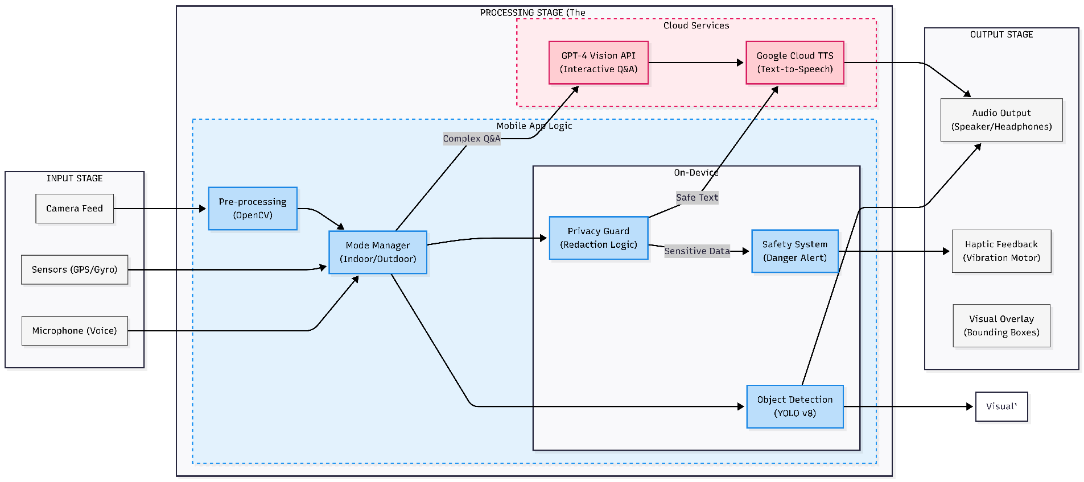

Prototype Description and Specifications
Please note that ITAC only funds projects that result in a prototype. Include a clear description of how the prototype will operate, explaining a scenario/use case of the operation. Also include the performance metrics you target in the prototype.
Prototype Description: The prototype is a comprehensive assistive mobile application designed to empower visually impaired users with independent navigation and document reading capabilities. It operates on a Hybrid Architecture that combines On-Device AI (Edge Computing) for immediate safety-critical tasks—such as obstacle detection and privacy protection—with Cloud-Based AI for complex scene understanding and detailed inquiry handling. This ensures the system is both responsive in dangerous situations and intelligent when detailed help is needed.

Scenario / Use Case of Operation:
- Outdoor Navigation: As the user walks outdoors, the app operates in "Navigation Mode." The local AI engine continuously scans the environment to detect dynamic obstacles (like cars or pedestrians) and static hazards. The user receives spatial audio feedback (left/right ear cues) to guide them safely around these obstacles without needing an internet connection.
- Smart Shopping: Inside a store, the user switches to "Reader Mode" and points the camera at a shelf. They can ask natural questions like "What flavor is this?" or "Is this the spicy version?" The system captures the image, processes it via the Cloud API, and verbally answers the specific question, filtering out irrelevant text.
- Secure Document Reading: When paying a bill, the user scans the receipt. The system’s Privacy Guard automatically detects sensitive patterns (such as credit cards or national IDs) on the table. It immediately suppresses the reading of these sensitive numbers, alerting the user to "Sensitive Data Detected," while successfully reading the remaining non-sensitive text (like the total amount).
Target Performance Metrics:
- Latency: The system is optimized for real-time processing, ensuring that obstacle detection warnings are delivered instantly to the user to prevent accidents.
- Accuracy: We target high detection accuracy for local objects and currency recognition, ensuring reliable identification in various lighting conditions.
- Privacy: The "Privacy Mode" is designed to achieve a zero-leakage standard for visible sensitive data (Credit Cards/IDs), ensuring no personal financial information is ever read aloud or transmitted.
- Battery Efficiency: The app is optimized to minimize power consumption during continuous camera usage, ensuring practical usability for extended periods outdoors.

Project Plan
Please define the approach and phases to deliver the intended project outcome.
Methodology: We will follow an Agile Software Development approach, organized into bi-weekly sprints. This allows for iterative development, frequent testing, and parallel work on the AI models and the mobile application.

Phases & Timeline:
- Phase 1: Planning & Requirement Analysis
  - Scope Definition: Finalize the functional requirements for indoor and outdoor assistance modes.
  - Data Acquisition: Collect and label local datasets essential for the project, such as Egyptian currency, local product brands, and traffic signs.
  - System Design: Design the system architecture and user interface (UI) wireframes focused on accessibility.

- Phase 2: Core System Development
  - Mobile App Foundation: Develop the core mobile application structure, including camera access and voice command interfaces.
  - Basic AI Training: Train the initial object detection models to recognize fundamental obstacles and outdoor elements (e.g., cars, people).
  - Integration: Connect the local AI models to the mobile app for real-time offline detection.

- Phase 3: Advanced Features Implementation
  - Cloud Integration: Integrate cloud-based AI services to handle complex tasks like reading documents and answering user questions (Interactive Q&A).
  - Privacy & Safety: Implement the local privacy algorithms to detect sensitive data (e.g., credit cards) and the safety alert system for danger warnings.
  - Audio Feedback: Develop the text-to-speech engine and directional audio cues to guide the user.
- Phase 4: Optimization & Testing
  - Performance Tuning: Optimize the application to ensure fast response times and low battery consumption.
  - User Testing: Conduct real-world scenarios to validate the accuracy of navigation and reading features.
  - Refinement: Fix identified bugs and fine-tune the user experience based on testing feedback.

- Phase 5: Final Delivery
  - Documentation: Complete the final project thesis and user manuals.
  - Deployment: Finalize the prototype for demonstration and prepare the project presentation.

Prototype Prospects
List the Egyptian ICT companies that may be interested in the developed prototype and the end-users/customers (name the specific class of individuals, governmental agencies, ministries … etc. that will benefit from the prototype)
List of ICT Companies:
- Etisalat Misr (e& Egypt): As a major telecom provider with strong CSR initiatives focused on disability and digital inclusion.
- Vodafone Egypt: Actively invests in assistive technologies and mobile solutions for societal impact.

Potential End-Users/ Consumers:
- Specific Class of Individuals: The visually impaired and blind community in Egypt (approx. 3.5 million), specifically those seeking Arabic-language support.
- Ministry of Social Solidarity (MOSS): For integration with disability support services (Karth El Khadamat).
- Ministry of Communications and Information Technology (MCIT): For alignment with national "ICT for People with Disabilities" initiatives.
NGOs & Institutions:
- Model Centre for the Blind (Zeitoun, Cairo): An educational hub ideal for piloting the navigation features.
- Al Nour Wal Amal Association: For distributing the tool to empower blind women.

